Name: _________________________ Group: _______
ENGLISH

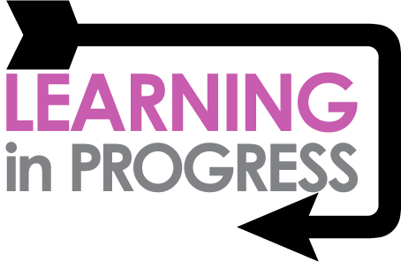

LANGUAGE
Definite and indefinite article
When do we use a or an or the?
Definite article( the)
We use the when we are talking about a specific object or person.
Example: Please return the book that you borrowed from me.
Indefinite article (a / an)
We use a or an when we are not referring to a specific thing or person.
Example: I bought a cell phone yesterday.
Using a or an
We use a before a singular noun. But if it starts with a vowel (a, e, i, o, u), we use an.
Example: There is an apple in my basket.
There is a banana in my basket.

Conjunctions
Conjunction | Examples
‘Because’ is used to show reason. | 1) I did not go swimming because it was raining.
‘Because’ is used to show reason. | 2) We could not sleep because it was too hot.
‘But’ is used to join two ideas that  are opposite. | 1) Pieter is poor but he is happy.
‘But’ is used to join two ideas that  are opposite. | 2) He fell into the drain but was not hurt.

Demonstrative pronouns
Singular
We say this is when it is near. We say that is when it is far.



That is a boat.
This is my house.



That is a bird.
This is my cat.

Plural
We say these are when they are near. We say those are when they are far.





Those are birds.
Those are stars.
These are my cats.

These are my new shoes.
Communication
Three parts of communication

Words 7%

Tone 38%

Body Language 55%

Words make up 7% of communication. To communicate successfully we have to know the meaning of the words.

Tone of voice make up 38% of communication.
Tone of voice is how we say something: Depending on how we say something, we can change the meaning of our sentence completely.
- THIS is mine.
- This IS mine.
- This is MINE.

Body Language make up 55% of communication.
Body language is the way we use our bodies to communicate.
Example: rolling our eyes, using our hands, the way we stand. Keep body language POSITIVE by:
- Making eye contact
- Keeping our hands open as opposed to clenched
- Smiling
- Standing up straight
- Leaning towards the person we are listening to
- Turning our head slightly towards the person talking

Three states of communication
When we communicate we can choose to communicate from a Parent, Adult or Child ego state.
Let me use an example to explain: remember when your mother had just cleaned the kitchen floor and you came running inside with muddy feet? You did not even notice that the floor was clean and that your feet were dirty. Your mother shouted: “Hey, you with the dirty feet, outside!” with her arm pointed towards the door.

Your mother was communicating from a Parent state. You felt hurt because it was not on purpose and you pushed out your lip saying: “It’s not my fault”. That was communicating from the Child state.

An Adult is where you use just logic, facts and reason to communicate. For example, your mother could say: “I have just washed the floor and your feet are dirty. Please go outside and clean them before you come in”. That is communicating from an Adult state.

We have parent, adult and child ego states in us at all times and depending on the situation, we react out of one of these states.
Hey , you with the dirty feet, outside!
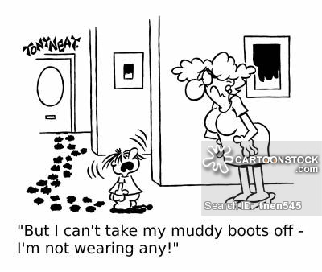
Communication
from three different states.

It’s not my fault.

I have just washed the floor and your feet are dirty. Please go outside and clean them before you come in.

Three levels of communication

1) Formal



When you speak to the manager of a company or when you go for an interview.


2) Informal

When you talk to friends you are more relaxed.

3) Personally

When you talk to someone whom you can share your secrets with.

Body Language
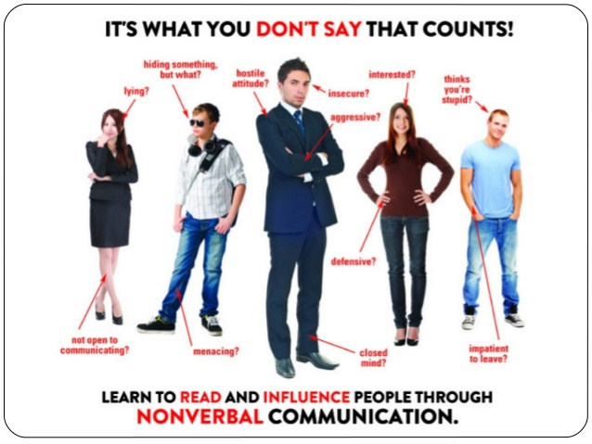
Positive body language

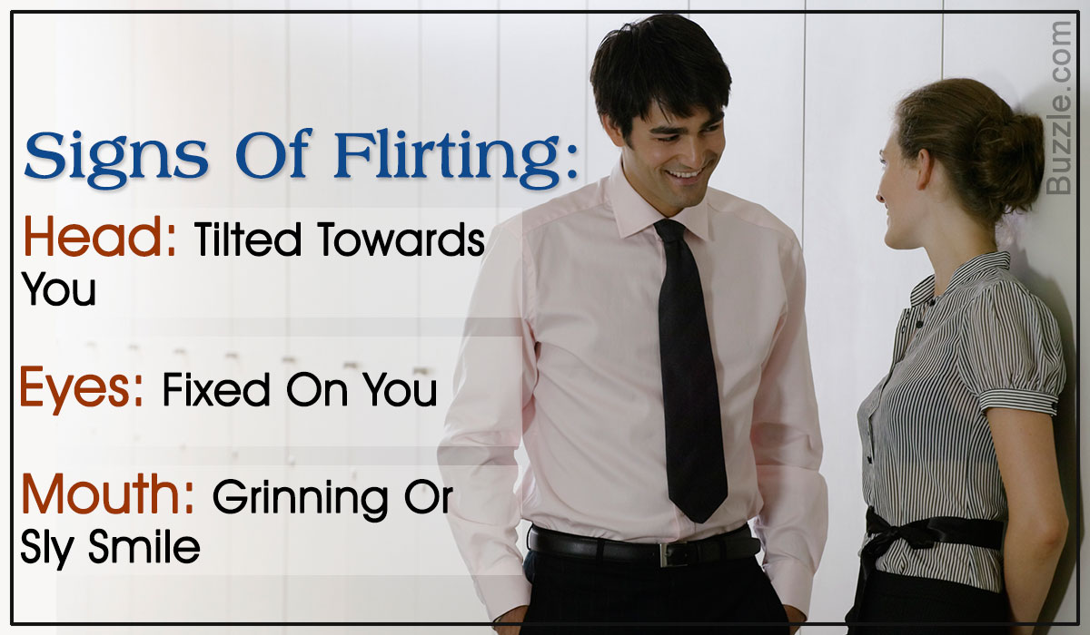
Happy / Excited

Friendly
Respectful

Negative body language
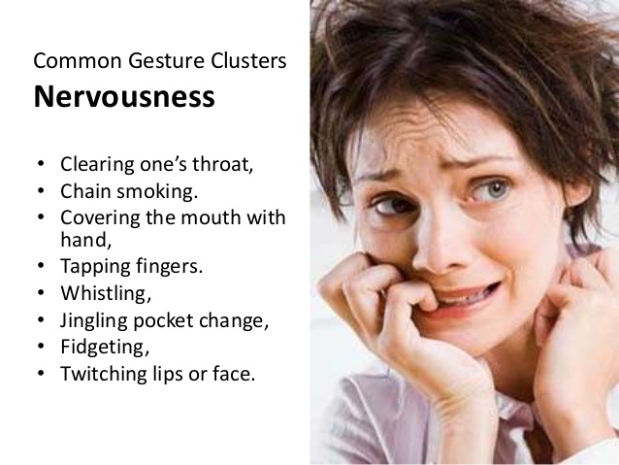
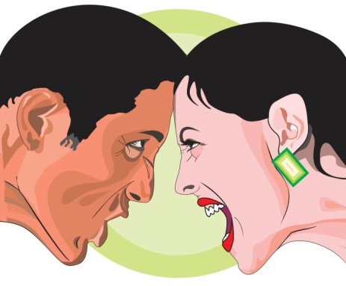


Anger

Unhappy
Sad
Hopelessness




Frustration



Punctuation
Punctuation marks don’t DO anything. They show you how to read texts.
Use these punctuation marks to show or indicate the END of a sentence.
! Exclamation marks show that a sentence is said louder or carries emotion.
? A question mark indicates that a question has been asked.
A full stop is used at the end of a sentence.
Use these punctuation marks to show or indicate a pause.
, A comma indicates that there is a pause in a sentence or that additional information has been added.
: A colon indicates that a list is to follow, introduces quotations and can come before direct speech.
Use these punctuation marks to show that words have been quoted.
, Thabo says, “Come, my friends, let’s eat! ”
: Thabo says: “Come, my friends, let’s eat! ”
“ ” Quotation marks
Use this punctuation mark [ ‘ ] to show that a letter has been left out or that an object belongs to somebody or something.
‘ The apostrophe indicates that a letter has been left out or that something belongs to somebody.
He didn’t know what to say.
(did not) Lerato’s book was on her desk.
D) Language Structure and Conventions
1. Direct and indirect speech

Vegetables are healthy.
Direct Speech



Mrs. Nkomo says that vegetables are healthy.
What does Mrs. Nkomo say?

Indirect Speech
(Reported Speech)

Word Sentence Level
2. Singular and Plural
Singular  (one) | Plural  (more than one) | Rule
day | days | copy the word and add -s
school | schools | copy the word and add -s
class | classes | We add –es to nouns  ending in s, x, ch & sh
box | boxes | We add –es to nouns  ending in s, x, ch & sh
fairy | fairies | y falls away add -ies
baby | babies | y falls away add -ies

3. Adjectives (describing words)
Nouns are the names of people or things. Adjectives tell us what the people or things are like.
- Mrs. Mkhonto arrived at school looking smart in her new car.
- Mrs. Mmela introduced a difficult topic in English.

4. Conjunctions

Definition of Conjunction
A conjunction is a word used to connect simple sentences to form a complex sentence.
- Mrs. Mkhonto arrived at school looking smart in her new car and she felt happy.

1. Mrs. Mkhonto arrived at school looking smart in her new car.
2. She felt happy.

5. Capital letters
- We use CAPITAL LETTERS in the beginning of sentences.
- Names of people and places are written with CAPITAL LETTERS.
5.1 A three year old girl has been pulled from a river by a schoolboy, Dumisani Mkize from the East Coast Primary School in
KwaZulu-Natal.

6. Pronouns
A PRONOUN is a word that takes the place of a noun.
Example: If we substituted pronouns for the nouns in the sentence “Please give the present to Karen,” it would read “Please give it to her.”

Check out the PRONOUNS
Joe’s teacher told the children that they must grow their own vegetables for their families. We can all help our families. We will enjoy ourselves while working in the garden. Vegetables give our bodies the vitamins we need.

LET’S LOOK AT TEXTS
Main Idea
The main idea of a text is the most important point that the author is making about the topic / subject.
The topic of this text is ladybugs. There are lots of detail you can learn about ladybugs from reading this text. What do the details tell you about ladybugs? Each detail tells about a different colour that ladybugs can be. So what main point or big idea is the author trying to make about ladybugs?

Ladybugs
Ladybugs are colourful beetles. Most
ladybugs have red wings with black spots.
Some ladybugs have orange or yellow
wings. One ladybug even has black wings

with red spots!

What’s the main idea?

Ladybugs can be many
different colours.

